**Ecosystem Stability**

Annie Walsh

MTH 381A: Math Modeling

Eli Goldwyn

December 13, 2023

### **Abstract**

In this paper, I am researching the impact a depleted predator population will have on an ecosystem. To do this, I will use Lotka-Voltera equations to model plant and prey populations. The number of predators will be a constant to make it easier to analyze the system. Using this system, I will plot a baseline system with no impacted predator population. Then, I will manipulate the predator population to see how a decreased population will impact plant and prey species. I will model this impact with a bifurcation diagram, a population vs time plot, and a population vs population plot.

### **Introduction**

In Yellowstone in the late 1800’s and early 1900’s, hunters killed almost the entire wolf population. The goal of these killings was to protect livestock and preserve the populations of trophy animals such as elk (“Wolf Restoration.”). However, this lead to unintended consequences. With their main predator gone, the elk population was able to grow virtually unchecked. This caused their food source, mainly willow trees, to be eaten faster than they could regrow. Now with fewer resources, the elk population, and other species, suffered.

While I am not modeling an existing ecosystem, I will model the impact of a decreased predator population. I was unable to find an existing model of a similar system but I used references to find some baseline numbers for my system. For example, I used “Lotka-Volterra Three Ways” to find general proportions for my Lotka-Volterra equations.

**Model**

To analyze the impact of a decreased predator population on an ecosystem, I will use a Lotka-Volterra system of equations to model a plant and prey population. The impact of the predator population will be seen in the death rate of the prey population.

Populations will be measured in thousands with a baseline predator population of .1, initial plant population of 100, and initial prey population of 10. The proportion of these numbers is what I found to be the case in the yellowstone example. I chose a baseline predator population of .1 because the current wolf population in yellowstone is about 100. This is to the extent that my model represents the yellowstone willow, elk, wolf populations. While I attempted to model my Lotka-Volterra equations on these populations, I was spending too much time getting the system to function somewhat realistically.

The rate of change in plant population is in the form: reproduction rate - prey impact rate. The rate of change in prey population is in the form: plant impact on reproduction rate - non predator caused deaths - predator impact rate. The plant population is x(t), prey population is y(t), and predator population is z.

Equations: ,

The z term in this system is not part of a Lotka-Volterra equation but I found that this system is easier to model and analyze than a system of three equations.

Shortfalls of this system include the plant population has an infinite capacity, prey and predators can eat as much as they want without getting full, and the predator population does not change.

### **Methods**

To analyze this system, I used the following code in python to create my population vs time, population vs population, and x’/y’ vs time graphs.

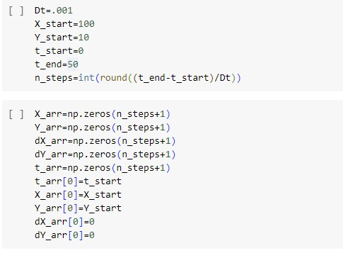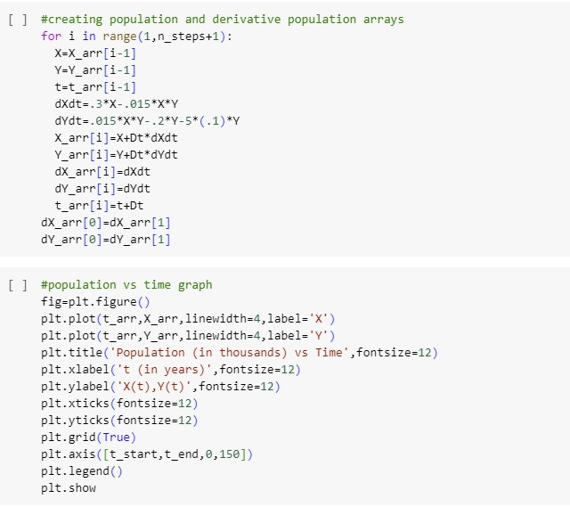

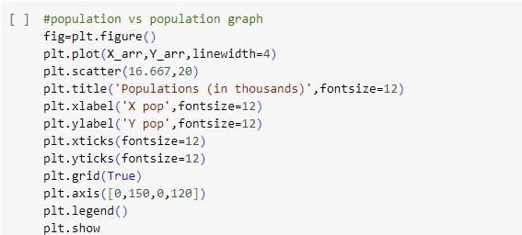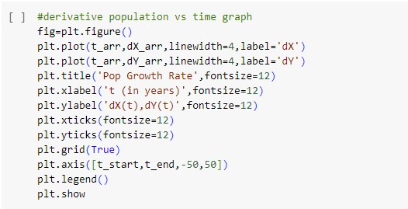

For more basic equations, I graphed using Desmos. To find and analyze equilibria I found nullclines, found equilibria from the nullclines, took partial derivatives to create a Jacobian matrix, and found the determinate and trace of the Jacobian matrix evaluated at the equilibria. I used Desmos to calculate the equilibria but everything else I did by hand.

### **Results**

#### **Baseline System**

My baseline (predator population = .1) graphs are shown below.

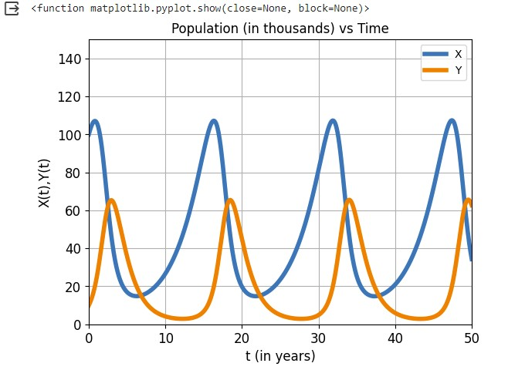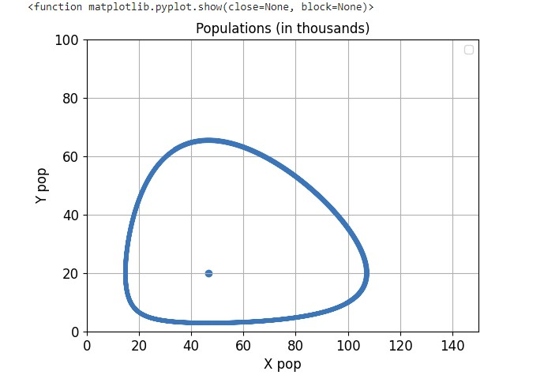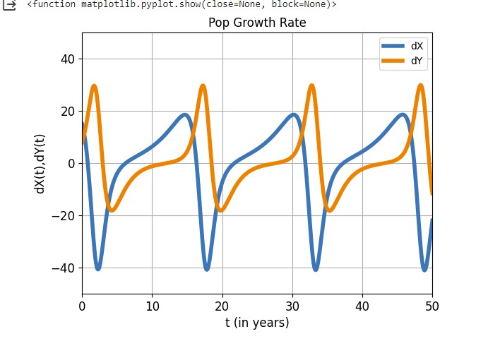

Based on the population vs population graph, it looks like this system has one center equilibrium but to test this, I used a Jacobian matrix. To do this, I first found the nullclines of the system. This is done by solving the derivative equations. This gave me the x-nullclines: and the y-nullclines . I graphed these equations in Desmos to find a nonzero equilibria of (4.67, 20). In each “section” mapped out by the nullclines, I found the sign of my derivative equations evaluated in these places to show the direction that a population vs population graph would move around my nonzero equilibrium. The resulting graph is shown below. It shows the plant population on the x axis and the prey population on the y axis.

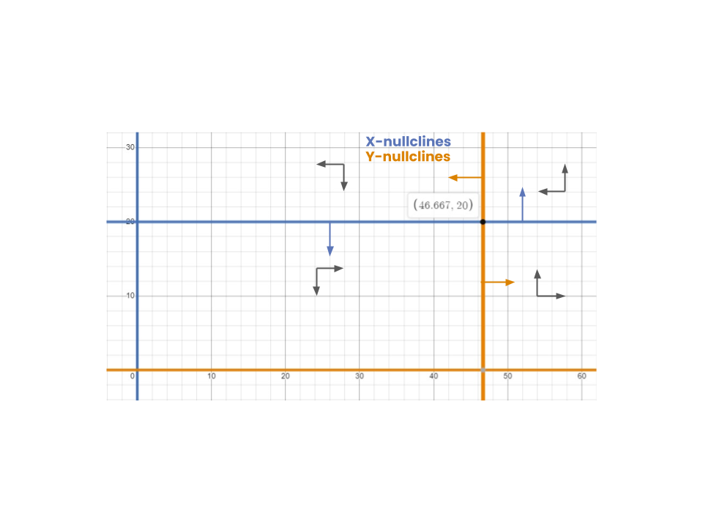

Now that I’ve found the equilibria, I need to determine its stability using a Jacobian matrix. To due this I set equal to F(x, y) and equal to G(x, y) the Jacobian matrix will then be: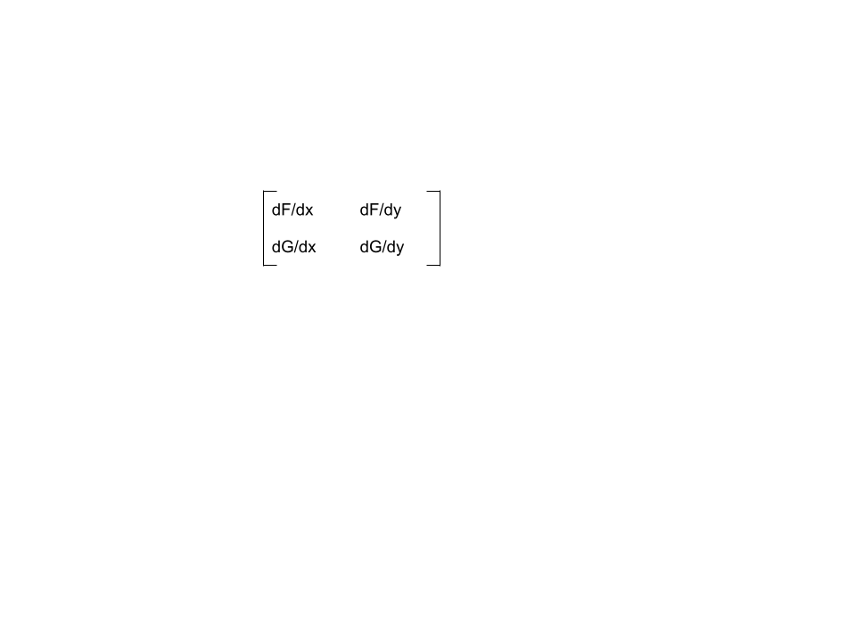I then calculated the partial derivatives to give: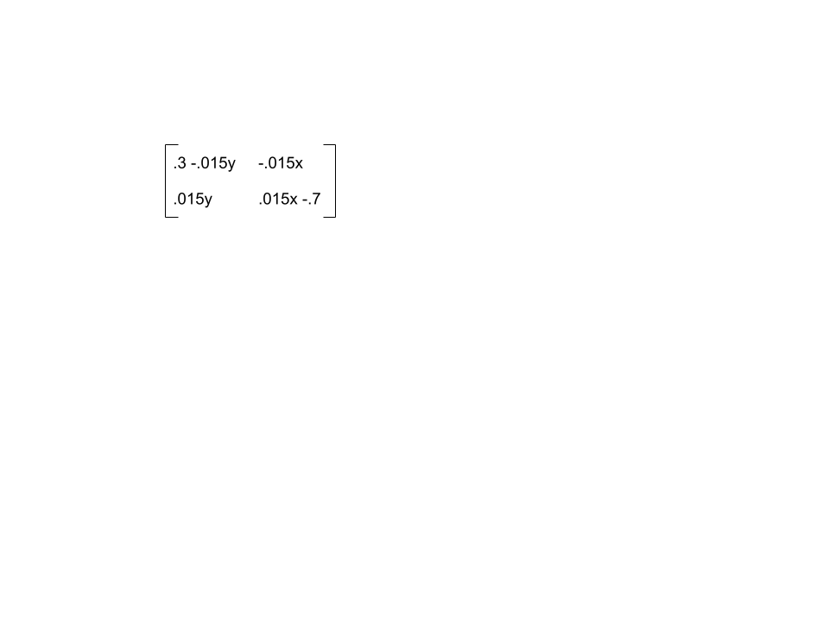

Next I plugged the equilibria into the matrix to get: 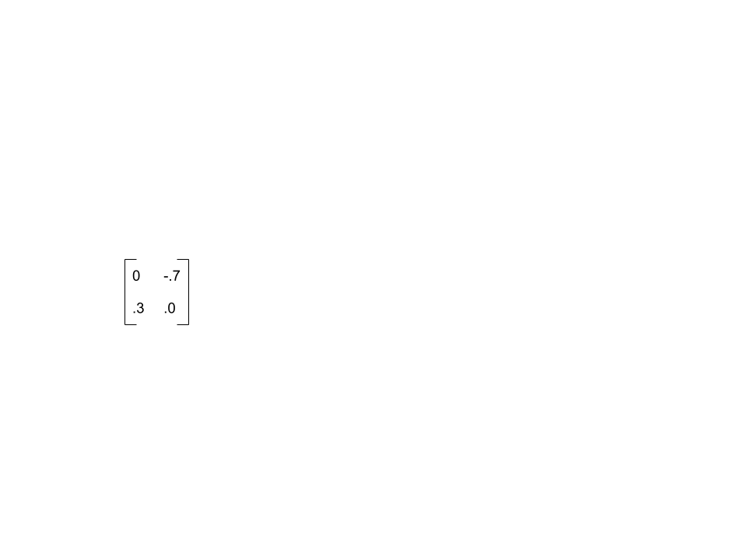

To determine the stability, I found the determinant and the trace of this matrix. The determinant = 0*0 - (-.7)*.3 = .21 and the trace = 0 + 0 = 0. Because the determinant is positive and the trace is zero, the equilibrium is a center point.

Conclusion:

When the predator population is not affected, the plant and prey populations will rotate around the center equilibrium point of (46.67, 20).

#### **Variable Predator Population**

Now to find the impact of a declining predator population, I need to make the population a changing variable. I am still using the equations , but I will have

I graphed two example scenarios in python using the same code as before but changing the value of z. When z=.05 (hunters remove 50 predators), I got the following population graphs:

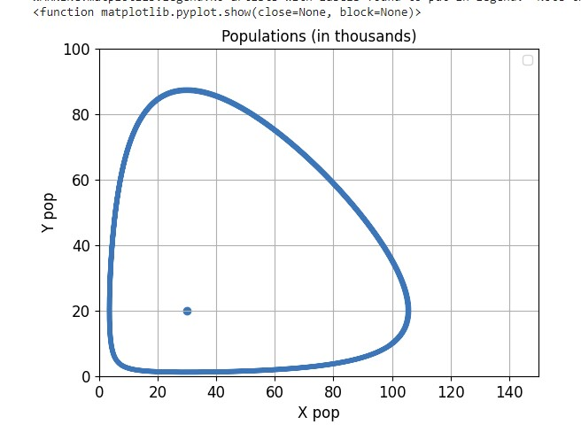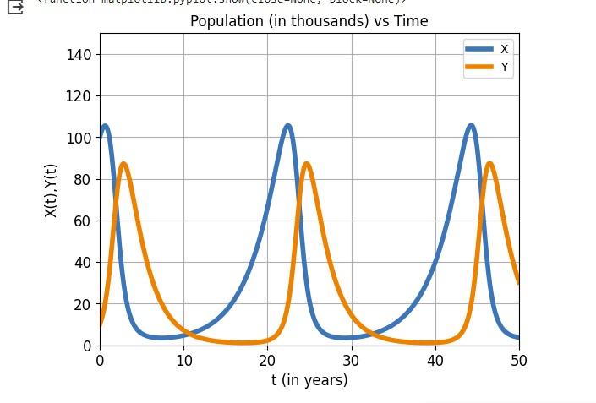

When z=.01 (hunters remove 90 predators) I got these population graphs:

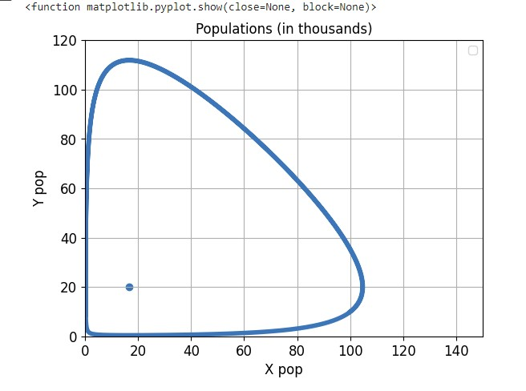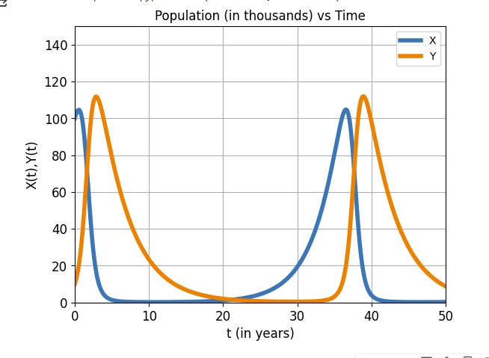

It appears that for both of these z values there is a center equilibria and to test this I repeated the previous method.

I repeated the methods used before to find the equilibria of the system as a function of z. To do this I first found the x-nullclines: and the y-nullclines . This shows that only the y-nullcline will change with z. This also shows the nonzero equilibria for this system will be (13.33 + 333.33z, 20). I graphed these equilibria vs z values in Desmos as shown below. This is also a bifurcation diagram (I will later prove that all these points are center points).

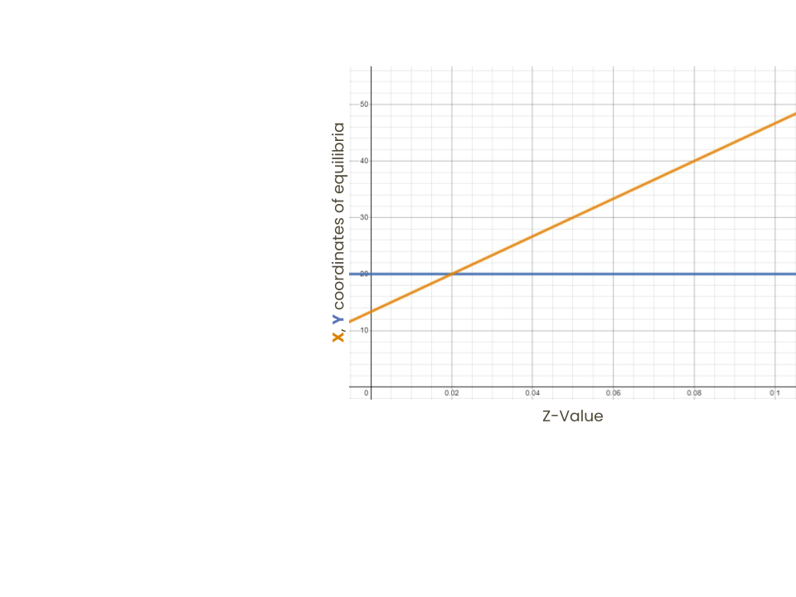

To find the stability for these equilibria I again made a jacobian matrix that included z.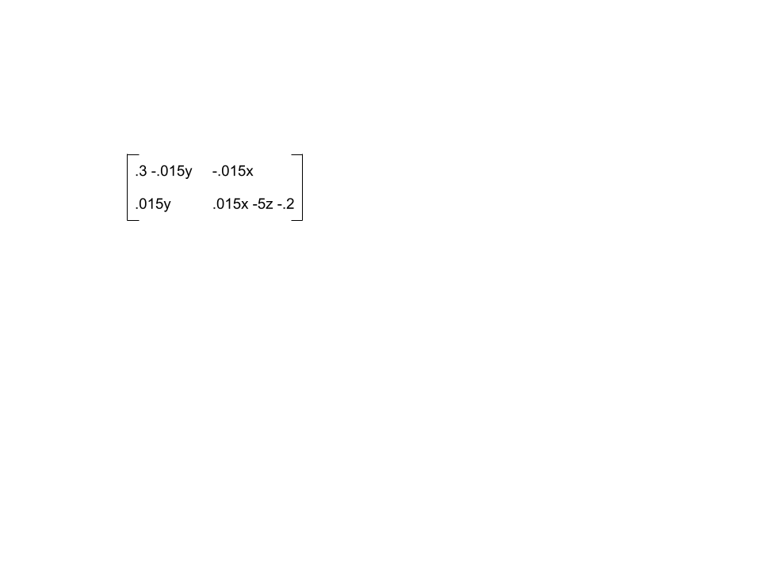 I then plugged in the variable equilibrium (13.33 + 333.33z, 20) into the matrix to get: 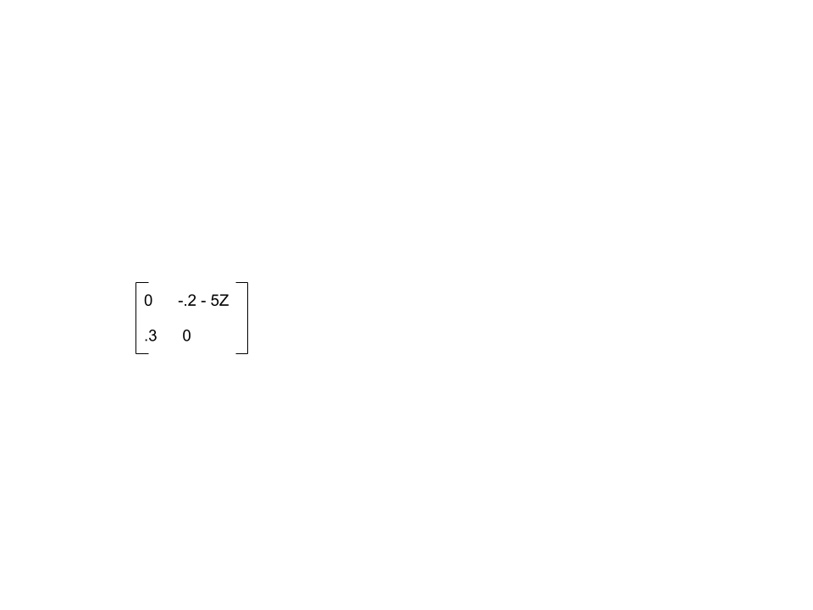

To determine the stability, I found the determinant and the trace of this matrix. The determinant = 0*0 - (-.2-5z)*.3 = .06+1.5z and the trace = 0 + 0 = 0. z<0 therefore, the determinant is positive and the trace is zero meaning the variable equilibrium is always a center point.

Conclusion:

When the predator population is affected, the plant and prey populations will rotate around the center equilibrium point of (13.33 + 333.33z, 20).

### **Conclusion**

My testing showed that no matter how many predators were removed, the plant(x) vs prey(y) system had a variable center equilibrium of (13.33 + 333.33z, 20) where z is the predator population and all populations are in thousands. This is not exactly what I was expecting to find but when I compared the graphs showing z=.1 and z=.01, I found evidence that removing a predator population damages plant and prey populations.



The difference between the no impact and impacted systems can be seen in the minimum plant and prey populations as well as the system “recovery” time.

In the no impact system, neither the plant or prey populations ever reach zero. However, in the impacted system, both populations reach approximately zero. In the real world if this happened, the populations would most likely not be able to recover naturally. However even if they are able to recover, the recovery time is much longer than the no impact system. In the no impact system, the populations oscillate about every 15 years. In comparison, the impacted system has oscillations about every 35 years. While this may not be mathematically unstable, this would be considered an unstable ecosystem because it has a much lower chance of recovery.

To further prove this point, one could use a more accurate system of equations than the Lotka-Volterra system that I used. As I said before, shortfalls of the system I used include the plant population has an infinite capacity, prey and predators can eat as much as they want without getting full, and the predator population does not change. If some of these shortfalls could be eliminated, one could make a more accurate system.

### **References**

“Wolf Restoration.” *National Parks Service*, U.S. Department of the Interior, www.nps.gov/yell/learn/nature/wolf-restoration.htm. Accessed 12 Dec. 2023.

“Lotka-Volterra Three Ways · Algebraicdynamics.Jl.” *· AlgebraicDynamics.Jl*, algebraicjulia.github.io/AlgebraicDynamics.jl/dev/examples/Lotka-Volterra/. Accessed 12 Dec. 2023.